Hunter Black

2657 Classens Blvd #110-C, Norman, OK, 73071 | 8175048660 | huntergblack@gmail.com

July 29, 2016

Dear OU IT:

I am writing in regards to the email I received about job listing number 162015, OU IT Community Experience Specialist for the Fall Semester. I am extremely interested in acquiring a position on the OU IT team. I believe that I would be an excellent fit for this position due to my 3 ½ years customer experience working as a cashier.

In addition to my experience in customer service, I have an extensive knowledge of both computer hardware and software, and am currently enrolled and on route to obtaining a degree in computer science. I have obtained varying levels of programming skills in Java as well as HTML, and am well learned in both Windows and Apple products. I also have a working knowledge of desktop computer hardware after having built my own desktop this past year.

After watching the attached video sent with the email regarding the position, my desire to work with the team at OU IT grew even more. I have always had a passion for technology, and to be able to utilize that passion with other people who share my interests is something that interests me greatly.

Attached is my resume, which I hope can further explain my appropriate skills for this position. I look forward to hearing a response. You can contact me at [huntergblack@gmail.com](mailto:huntergblack@gmail.com) or by phone at (817-504-8660). Thank you for your consideration.

Sincerely,

Hunter Black

**Hunter Black**

3003 Lake Drive | Southlake, TX 76092 | [Hunter.G.Black-1@ou.edu](mailto:Hunter.G.Black-1@ou.edu) | 817-504-8660

|  |  |  |
| --- | --- | --- |
| **EDUCATION** |  | **University of Oklahoma, Norman, OK**  ­Overall Current GPA 3.74 |

|  |  |  |
| --- | --- | --- |
| **EXPERIENCE** |  |  |
| ­May 2013 - August 2016 |  | Cafe Express  *Cashier*   * Worked up from bus boy to cashier * Worked closely with a team of people to deliver exceptional customer service * performed multiple duties around the restaurant, including: bussing, food preparation, catering/deliver, and cashiering­ |

|  |  |  |
| --- | --- | --- |
| **SKILLS** |  | **Computer Skills**   * Languages: Java, HTML * Application Software: Microsoft Office Suite, Eclipse * Operating Systems: Microsoft Windows, Mac OS X   **Leadership**   * Drum Major - Carroll Dragon Marching Band * Member – Big Event Ops Staff |

|  |  |  |
| --- | --- | --- |
| **HONORS AND AWARDS** |  | * Dick & Shirley O’Shields Engineering Scholarship * Honors College * Oklahoma Award of Excellence 4-year scholarship * College of Engineering 4-year scholarship * National Honor Society * Dean’s List (Fall 2015) |

|  |  |  |
| --- | --- | --- |
| **Community Service / Volunteer** |  | * Aid in construction of greenhouse out of recycled materials * Involved with organization of GRACE Gala involving creating invitations, setting up and breaking down event * Aid in setting up GRACE glow golf benefit event * Member of the Big Event Ops staff, coordinating volunteers and supplies between work sites |

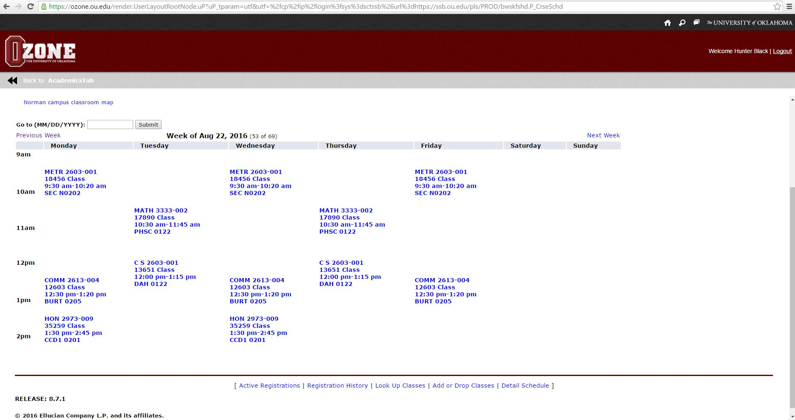

Fall 2016 Class Schedule